15thCaribbean Cuboree
CUBBING: A UNIVERSE OF FUN
THE SCOUT ASSOCIATION OF JAMAICA
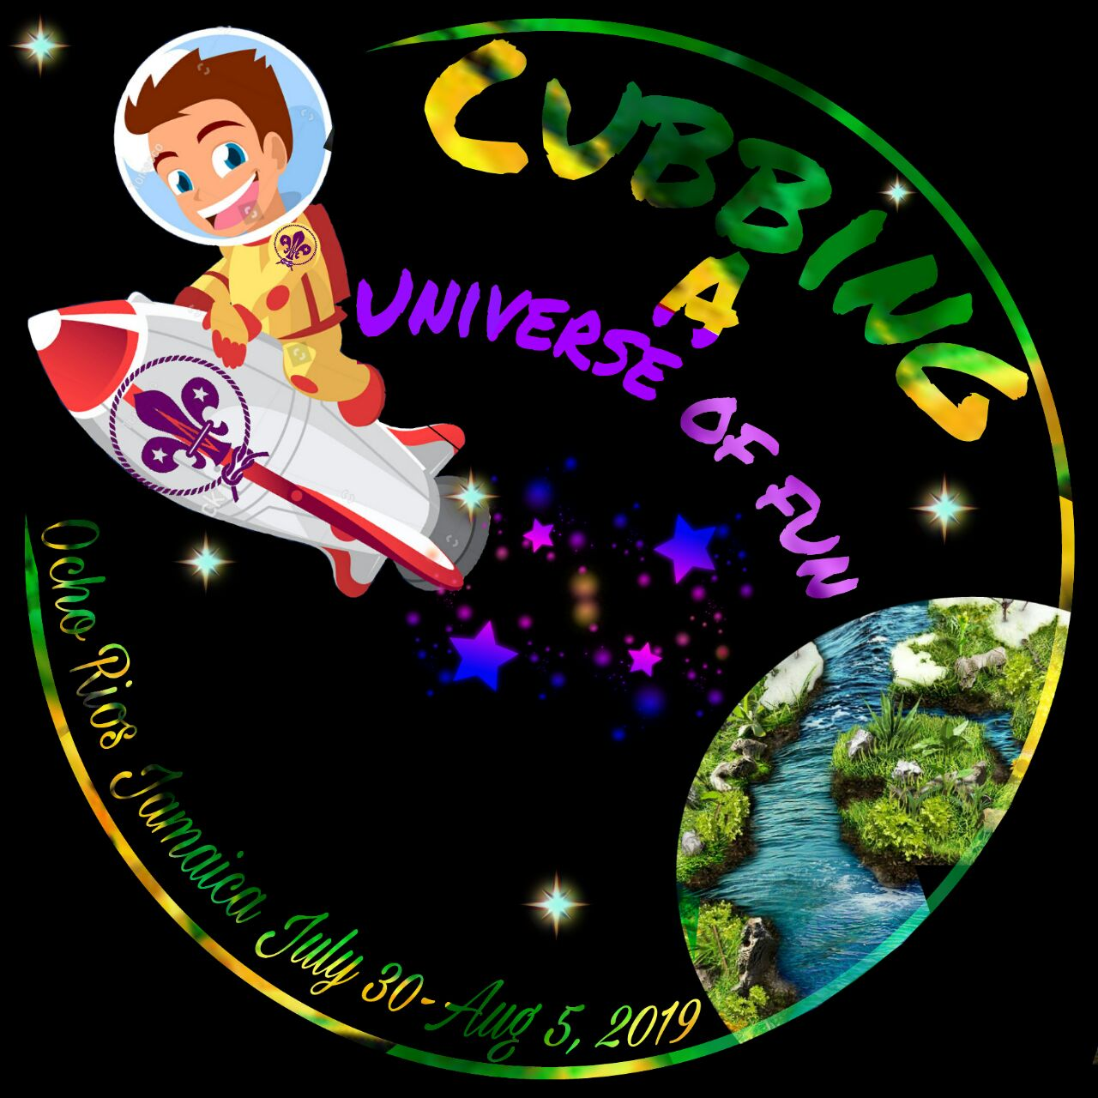
Pre-Registration  The “Online Pre-Registration form” is now available for contingent leaders to give basic information regarding their contingent. Please complete and submit before September 30, 2018 | International Service Team  To assist in the preparation and execution of a memorable Cuboree, ISTs are invited to apply to work as a part of the Cuboree team. Complete the online registration form and submit by September 30, 2018. |  | Payment methods  There are different ways in which NSOs can make payment on their contingent’s behalf. Details of these methods are given in the link below.
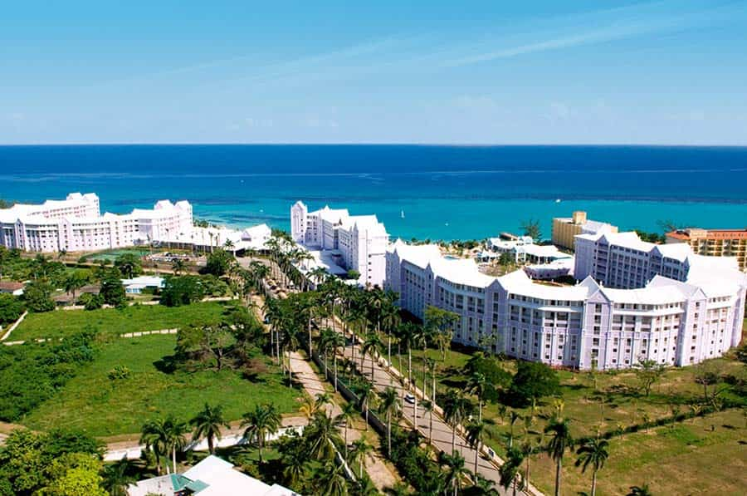 |  | Contingent leaders’ visit  Contingent leaders are invited to visit the Cuboree site in Ocho Rios on October 5-7, 2018. During this visit contingent leaders will get to tour the campsites, speak with the Cuboree committee, visit some of the activity sites and enjoy some Jamaican hospitality. Please indicate your intention by email by August 31, 2018.

Equipment and meal
- Tabletop two-burner gas stoves will be available for rental at a cost of 50 USD for the duration of the Cuboree. Gas for the stoves will be available for purchase at a cost of 35 USD.

- Pots, pans, basins, utensils etc. will be available for purchase from stores close to the campsite.

- The Cuboree is a fascinating experience and meals are always a high point for participants. We are very proud of the Jamaican cuisine, and participants will be able to sample many of our dishes. However, customs and culture differ and the palate, especially of our Cub Scouts, may be biased to their own country’s cuisine. Contingents are advised to delegate adults to prepare meals for their contingent. A price list for common food items will be sent as an appendix in bulletin #3. This will help contingents plan their menus.

Hotels and Guest Houses
Families and friends are invited to our beautiful island to enjoy the attractions we have to offer.
A list of nearby hotels and guest houses, along with cost and contact information, will be made available through the Cuboree website.
International Service Team (IST)
The 15th Caribbean Cuboree is inviting persons, at least 18 years of age, to apply to work as a part of the IST. This opportunity will allow you to develop leadership skills and become great team players. Please use the online form to apply.
ISTs will pay 100 USD. 50 USD to is to be paid in October. If Full payment is received by March 2019 a discount of 10 USD will be given.
Airports  Contingents can plan their flights through either of two airports; The Norman Manley International Airport (Kingston) or The Donald Sangster International Airport (Montego Bay). Both are about 90 minutes from the campsite. Norman Manley is the most popular route.  Contingents will be transported from and to the airport of their choice as part of the Cuboree package.  Once travel arrangements are finalized, contingent leaders can indicate their travel itinerary on the approved form which will be available in Bulletin # 5. | 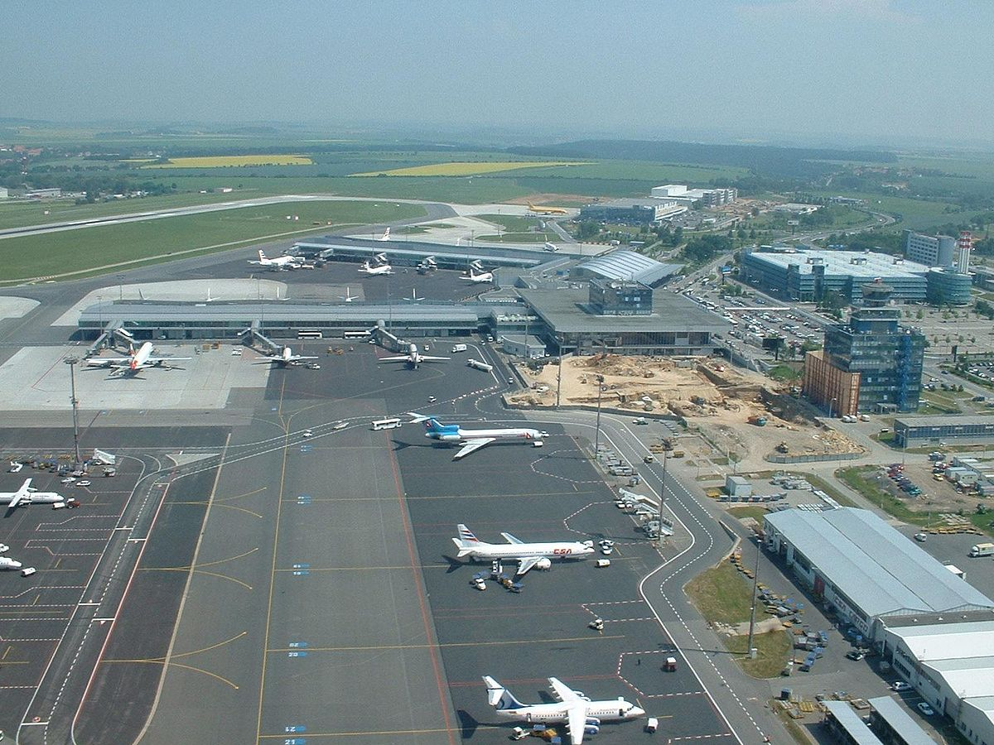
Use the following link for Foreign exchange rates: http://www.boj.org.jm/foreign_exchange/fx_crates.php  Payment Schedule  Cuboree payments can be made in parts according to the following Schedule:  50 USD: October 2018  20 USD: February 2019  30 USD: April 2019  50 USD: July 2019 | Full payment by March 2019 will receive a discount of  20 USD  Cuboree payments can be made by wire transfer or through Western Union ®
- Bulletin #1 stated that the minimum age for Cubs attending the Cuboree is 8 years, we want to officially state that the minimum age is 7 years!

Wire Transfer Information

INTERMEDIARY BANK INFORMATION
Intermediary Bank Name: Bank of America
Intermediary Bank Address: 100 SE 2nd St., Miami, Florida 33131, USA
Fed Wire: 026009593
SWIFT: BOFAUS3N

BENEFICIARY BANK INFORMATION
Beneficiary Bank Name: Sagicor Bank Jamaica Limited
Beneficiary Bank Address: 17 Dominica Drive, Kingston 5, Jamaica WI
SWIFT: SAJAJMKN

BENEFICIARY INFORMATION
Beneficiary Name: The Scout Association of Jamaica
Beneficiary Address: 2D Camp Road, Kingston 5, Jamaica WI
Beneficiary Account Number: 5501010032

Purpose of Wire: 15th Caribbean Cuboree
Additional Information: Name of Country

Bulletin Schedule:
Bulletin #1- February 2018
Bulletin #2- June 2018
Bulletin #3- September 2018
Bulletin #4- January 2019
Bulletin #5- May 2019
Here are some very important links…
Website- https://15thcaribbeancuboreejamaica.weebly.com/
Facebook: https://www.facebook.com/15thCaribbeanCuboreeJamaica/?hc_location=group_dialog
Pre-Registration Form: https://docs.google.com/forms/d/e/1FAIpQLSdlQBMaEh_62XsXEn9zdQqy-HqbTxWWjwVgb7ZjsYYD44luRQ/viewform
IST Form: https://docs.google.com/forms/d/e/1FAIpQLSfBbJYQpB6PlPZ0HwrjFfYUFRfWplHvLb6pWSDtnhADBGYBkA/viewform

Contact Us

Contact us
Email: 15caribbeancuboree@scoutjamaica.org
Secretariat Phone: 876 648-9966
Scout Jamaica Office: 876 926-7209

